BI DEPLOYMENT, MONITORING AND DISASTER RECOVERY REPORT

Objective: To present a deployment, workspace management, monitoring, backup and recovery strategy for the Global Superstore BI solution.

BI Deployment Plan: The solution includes the Global Superstore dataset, Executive Dashboard, Sales Report, Profit Report and Regional Report. The CEO and department managers are the intended users. The BI Administrator maintains the dataset and manages deployment. The objective is to provide authorized users with reliable business information.

Workspace and Role Structure: A centralized Power BI workspace is proposed. Access is assigned according to each user's responsibilities.
Role | Responsibility | Responsible Person
Admin | Everything, including managing users, deleting the workspace and changing settings | BI Administrator
Contributor | Create and edit content and publish, but cannot manage users or share the workspace | BI Developer / Analyst
Member | Edit content, publish, share and add users with lower roles | Senior BI Developer
Viewer | View reports and dashboards only (RLS applies to this role) | CEO, managers, general users

Monitoring Strategy:
The BI solution should be monitored to identify refresh failures, usage changes, performance issues and unusual user activity.
Metric | What it shows | How it’s Monitored | Frequency | Responsible
Access and permissions | Unauthorised or outdated access | Workspace access review | Quarterly | BI Administrator
Alerts and subscriptions | Whether notifications are delivered | Alert and subscription status | Weekly | BI Operations
Dashboard usage statistics | Views, viewers and popular reports | Usage metrics report in Power BI Service | Weekly | BI Analyst
Data quality | Missing or wrong values after refresh | Spot checks of KPI totals against the source | Weekly | BI Analyst
Dataset refresh status | Whether scheduled refreshes succeeded or failed | Refresh history in Power BI Service, with failure email notifications | Daily | BI Administrator
Report performance | How long visuals take to load | Performance Analyzer in Desktop, and user feedback | Before release, and monthly | BI Developer
User activity | Who accessed or changed what | Admin activity log / audit logs | Weekly | IT Security / BI Admin

5. Backup Schedule
Backup | Frequency | What it Saves | Stored in | Retention | Owner
Dataset / source data backup | Daily | Source Excel and dataset files | Cloud storage (OneDrive / SharePoint) | 30 days | BI Administrator
Report backup | Weekly | Latest .pbix of every report | Version-controlled folder | 12 weeks | BI Developer
Workspace archive | Monthly | All .pbix files, security and refresh settings, documentation | Separate archive location | 12 months | BI Administrator

6. Restore Procedure
Action | Time
Confirm the deletion, check the workspace first, and inform the Administrator | 0–30 min
Retrieve the latest .pbix from backup storage | 30–60 min
Open it in Desktop, refresh the data and check visuals | 1–2 hours
Republish to GS_Production, reconnect the data source, reset the refresh schedule | 2–3 hours
Reassign sharing, subscriptions, alerts and RLS role members | 3–4 hours
Validate KPI totals against the source and test access with a Viewer account | 4 hours
Confirm with the executives that the dashboard is ready | Before the meeting

Disaster Recovery Scenario:
Scenario: When the executive dashboard was accidentally deleted, the BI Administrator would restore it from the most recent weekly backup of the report file, republish it to the production workspace, reconnect the data source and restore the access settings. The dashboard would be validated against the source data before the meeting, and a PDF snapshot from the monthly subscription would serve as a contingency, ensuring business continuity.

Business Continuity Recommendations:
- Keep dated copies of important PBIX files in an approved secure location.
- Maintain backups of source datasets and document data connections.
- Restrict delete and publish permissions to authorized workspace roles.
- Test restoration procedures periodically.Keep a secondary copy of critical reports for urgent management requirements.
- Record recovery actions and notify users when service is restored.

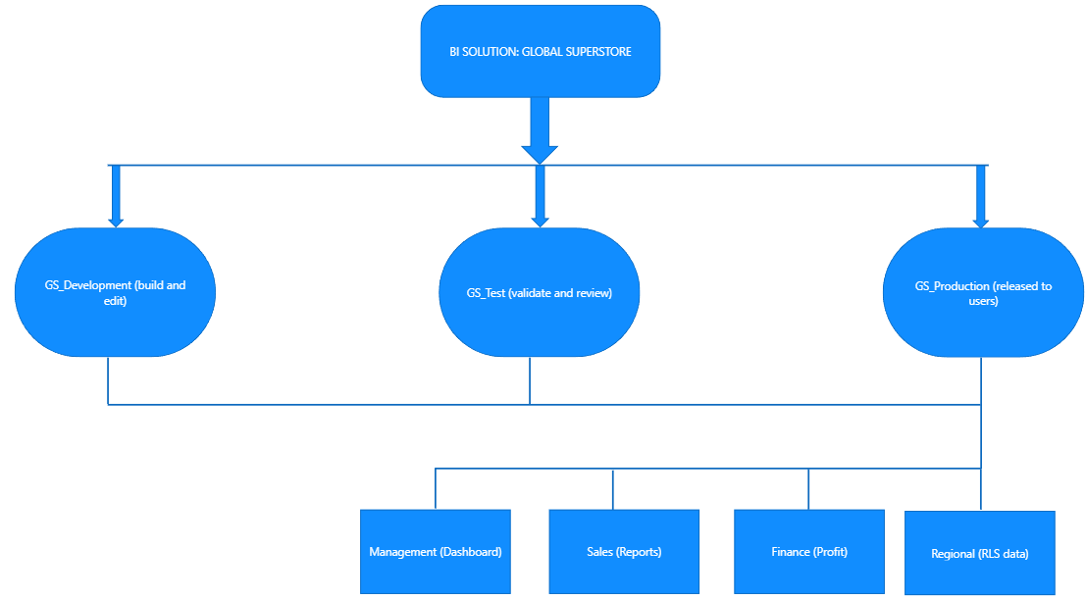
Conclusion: A BI deployment and maintenance strategy was designed for the Global Superstore solution. Workspace roles, monitoring metrics, backup schedules and restore procedures were documented. The disaster recovery scenario demonstrates how a verified PBIX backup can help restore a deleted dashboard and support business continuity. These are proposed plans; actual deployment, monitoring and backup automation must be configured in Power BI Service and the organization's storage environment.

